What is CRID?
CRID, or Clinical Research Identifier, is a unique identifier for patients participating in clinical research studies. This identifier is generated by the patient or their parent and serves as a secure and consistent way to identify a patient's information across multiple research studies.
Is CRID Secure?
Yes, CRID takes security seriously. All CRID data is stored on secure Amazon AWS servers and is encrypted both in the database and while in transit. Additionally, we do not use Google Analytics.
CRID Principles
• CRID is always free for the parent/patient
• CRID is always optional for research studies
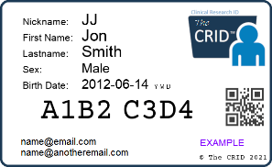
• CRID data is private and will never be sold or shared with any third parties
What does a CRID look like?
A CRID identifier is an 8-character random string of letters and numbers that is unique to each patient.
How to use the CRID?
Patients can share their CRID identifier with investigators on research studies they are or have been enrolled in.
Why use CRID?
Many patients are unaware that their data is not shared with other researchers working on the same or similar diseases. They may also experience "survey fatigue" from being asked to complete similar forms for multiple studies. CRID allows for the sharing, reuse, and merging of data across studies by connecting deidentified patient information.
How do I create my CRID identifier?
To create a CRID identifier, visit the website https://TheCRID.org. If you do not already have an account, click on [Create an Account]. If you have an account, click on [Login]. To create a new CRID identifier for yourself or a family member, click on the [Add a New Person] button. There is also a short training video available on the website that demonstrates this process.
https://TheCRID.org

If you have any questions or concerns about CRID, or if you need assistance, you can send an email to info@thecrid.org.

